# MarkIt - Technical Design Document

## Table of Contents

1. Introduction
2. System Overview
3. Architecture
   1. High-Level Architecture

○ Component Interactions

1. Backend Design
   1. Technologies Used

○ Project Structure

○ API Design

○ Database Schema

○ Middleware

1. Frontend Design
   1. Technologies Used

○ Project Structure

○ Routing

○ State Management

○ Key Components

1. Security Considerations
2. Deployment Plan
3. Unit Testing
4. Future Plans
5. Conclusion

# Introduction and System Overview

## Introduction

**MarIt** is a modern blog-sharing platform designed to enable users to create, share, and discover articles on various topics. The platform offers a seamless user experience with features like real-time updates, user authentication, article management, and social interactions such as upvoting.

This design document provides a comprehensive overview of the project's architecture, components, technology stack, and design decisions. It aims to serve as a guide for developers, stakeholders, and contributors.

## System Overview

MarIt is built using the MERN stack (MongoDB, Express.js, React, Node.js), utilizing modern web development practices. The application is structured to provide scalability, maintainability, and a responsive user experience across devices.

# Architecture

## High-Level Architecture

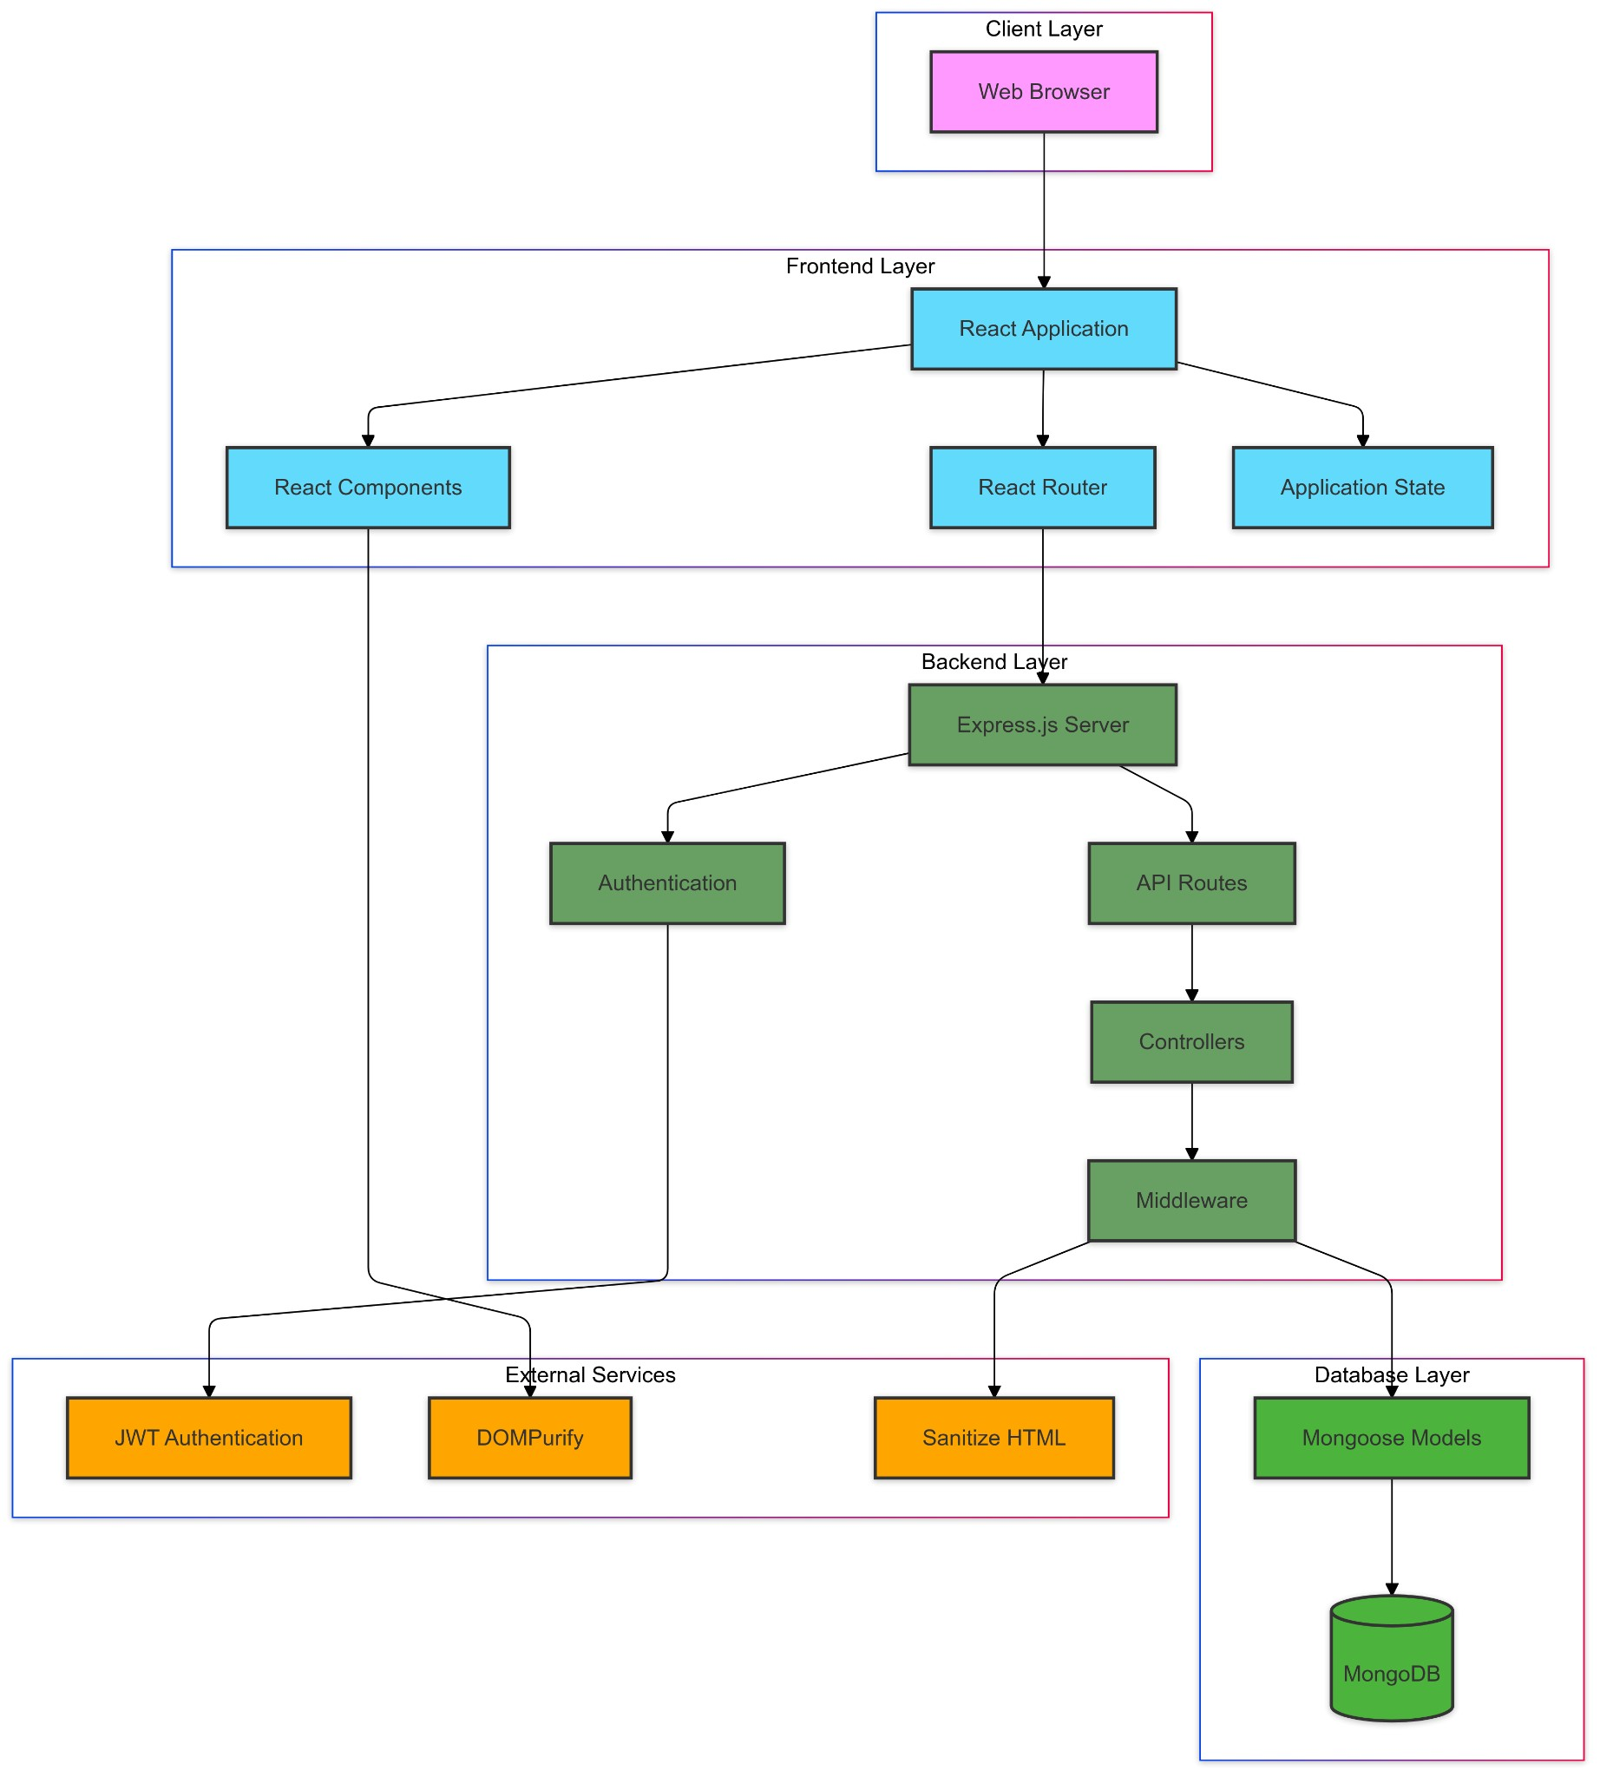

The system follows a three-tier architecture, comprising:

1. **Frontend**: Developed with React.js, responsible for the client-side user interface and interactions.
2. **Backend API**: Built with Express.js and Node.js, handling server-side logic, API endpoints, authentication, and business logic.
3. **Database**: Utilizes MongoDB for storing user data, articles, and related information.

# Backend Design

## Technologies Used

* **Node.js**: JavaScript runtime environment.
* **Express.js**: Web application framework for building APIs.
* **MongoDB**: NoSQL database for data storage.
* **Mongoose**: ODM (Object Data Modeling) library for MongoDB.
* **JWT**: JSON Web Tokens for authentication.
* **bcrypt**: Library for hashing passwords.

## Project Structure

* **index.js**: Entry point of the server application.
* **middleware/**: Contains middleware functions, including authentication.
* **models/**: Mongoose schemas for User and Article models.
* **routes/**: Defines API endpoints for authentication, users, and articles.
* **generateArticles.js**: Script for generating sample articles (used for testing or demonstration).

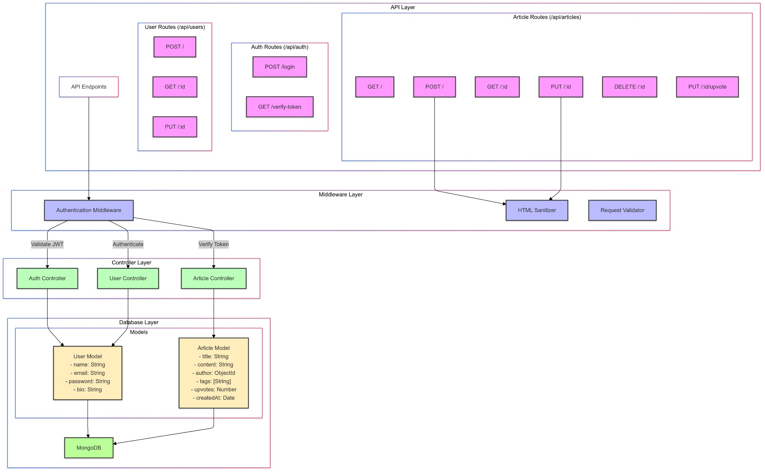

# Backend Design - API, Database Schema and Middlewares

## API Design

The backend exposes RESTful API endpoints categorized under:

* **Authentication (/api/auth)**
  1. POST /login: User login and JWT token issuance.
* **Users (/api/users)**
  1. POST /: User registration.

○ GET /:id: Retrieve user profile and their articles.

○ PUT /:id: Update user profile.

* **Articles (/api/articles)**
  1. GET /: Fetch a list of articles with pagination and sorting options.

○ POST /: Create a new article.

○ GET /:id: Retrieve a specific article.

○ PUT /:id: Update an existing article.

○ DELETE /:id: Delete an article.

○ PUT /:id/upvote: Upvote an article.

# Database Schema

**User Model (User.js)**

**Fields:**

* **name** (String, required): User's full name.
* **email** (String, required, unique): User's email address.
* **password** (String, required): Hashed password.
* **bio** (String, optional, default: ""): Short biography.

**Indexes:**

* Unique index on **email** for ensuring unique user emails.

**Relations:**

* A user can author multiple articles.

**Notes:**

* Passwords are hashed using bcrypt before being saved, as defined in userSchema.pre("save").

**Article Model (Article.js)**

**Fields:**

* **title** (String, required): Title of the article.
* **content** (String, required): Main content/body of the article.
* **author** (ObjectId, required): References the **User** model.
* **tags** (Array of Strings): Keywords associated with the article.
* **upvotes** (Number, default: 0): Count of upvotes received.
* **createdAt** (Date, default: Date.now): Timestamp of creation.

**Indexes:**

* Index on **createdAt** for chronological sorting.
* Index on **upvotes** for sorting popular articles.

**Relations:**

* Each article is associated with an author (user).

**Notes:**

* The **author** field establishes a relationship between articles and users.
* Articles can have multiple tags for better categorization.

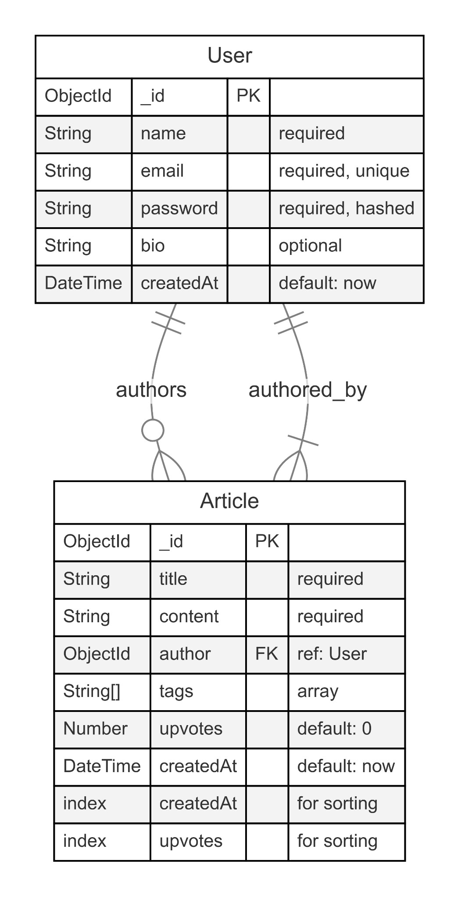

## Middlewares

### Authentication Middleware (auth.js)

* Validates JWT tokens sent in the Authorization header.
* Attaches the authenticated user's information to the request object. ● Protects routes that require authentication.

# Frontend Design

## Technologies Used

* **React.js**: JavaScript library for building user interfaces.
* **React Router DOM**: Handling client-side routing.
* **Tailwind CSS**: Utility-first CSS framework for styling.
* **Vite**: Build tool for faster development.
* **ESLint**: Linting utility to maintain code quality.

## Project Structure

* **main.jsx**: Entry point of the React application.
* **App.jsx**: Main application component.
* **components/**: Reusable UI components.
* **pages/**: Page components corresponding to routes.
* **routes/**: Defines client-side routing.
* **lib/**: Utility functions.
* **index.css**: Global CSS and Tailwind directives. ● **public/**: Static assets.

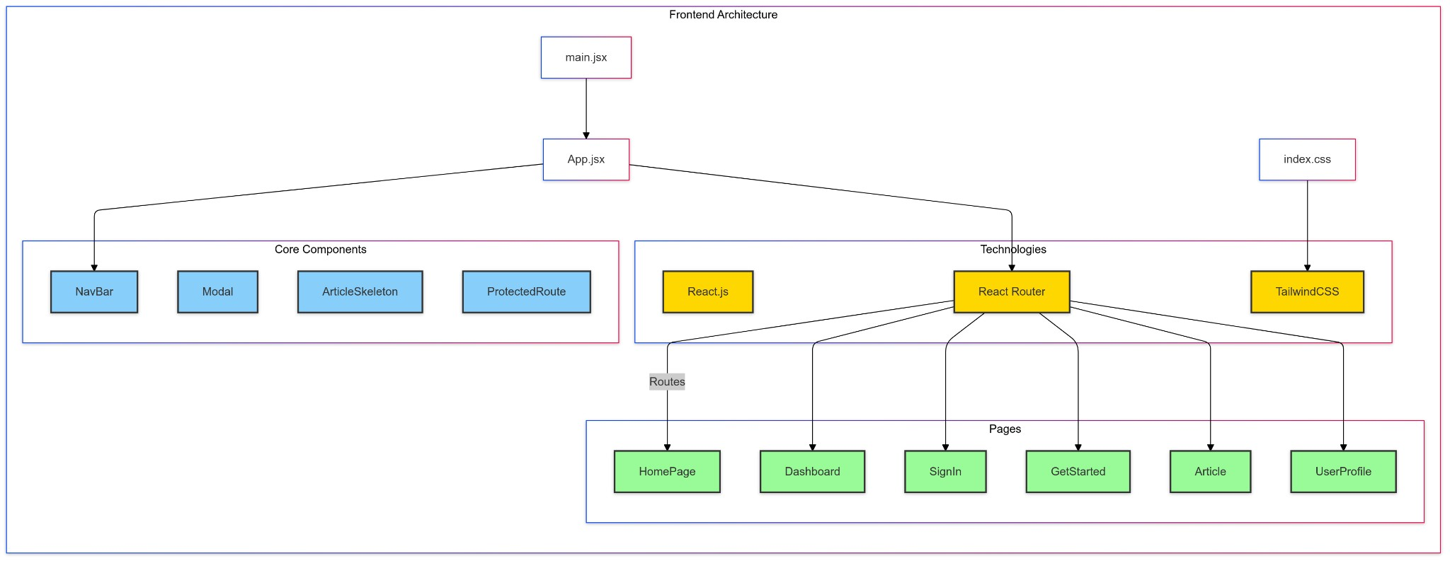

# Frontend Design - Routing, State Management and Key Components

## Routing

Implemented using React Router:

* /: Home page.
* /getstarted: User registration page.
* /signin: User login page.
* /dashboard: User's personalized feed.
* /articles/:id: View a specific article.
* /new-article: Create a new article.
* /articles/:id/edit: Edit an existing article.
* /users/:id: View a user's profile.

## State Management

* **Local State**: Managed using useState and useEffect hooks.
* **Authentication State**:
  1. Stored in localStorage.

○ Accessed via custom hooks or utility functions.

* **Data Fetching**:
  1. Utilizes fetch API.

○ Handles loading and error states.

**Key Components**

## NavBar

* Displays navigation links.
* Shows different options based on authentication state.
* Includes a logout mechanism.

## Modal

● Generic modal component for displaying messages and actions. ● Used for confirmations, alerts, and information display.

## ArticleSkeleton

* Placeholder component displayed during data loading.
* Enhances user experience by indicating content is being fetched.

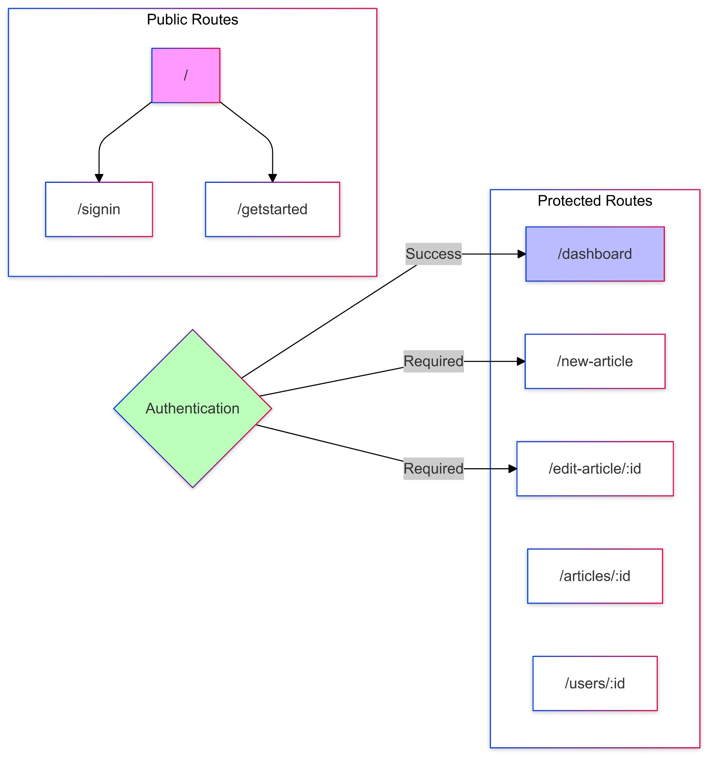

# Security Considerations

## Authentication

* **JWT Tokens**:
  1. Securely generated and signed with a secret key. ○ Stored in the client's localStorage.
* **Password Security**:
  1. Passwords hashed using bcrypt before storing in the database.

○ Plain passwords are never stored or logged.

## Authorization

* **Protected Routes**:
  1. Backend routes require valid JWT tokens.

○ Frontend routes use higher-order components to restrict access.

* **Input Validation**:
  1. Sanitization of inputs to prevent injection attacks.

○ Validation rules applied on both client and server sides.

## CORS Configuration

● **Access-Control Policies**:

○ Configured to allow requests from trusted origins.

○ Proper headers set for Access-Control-Allow-Origin, Methods, and Headers.

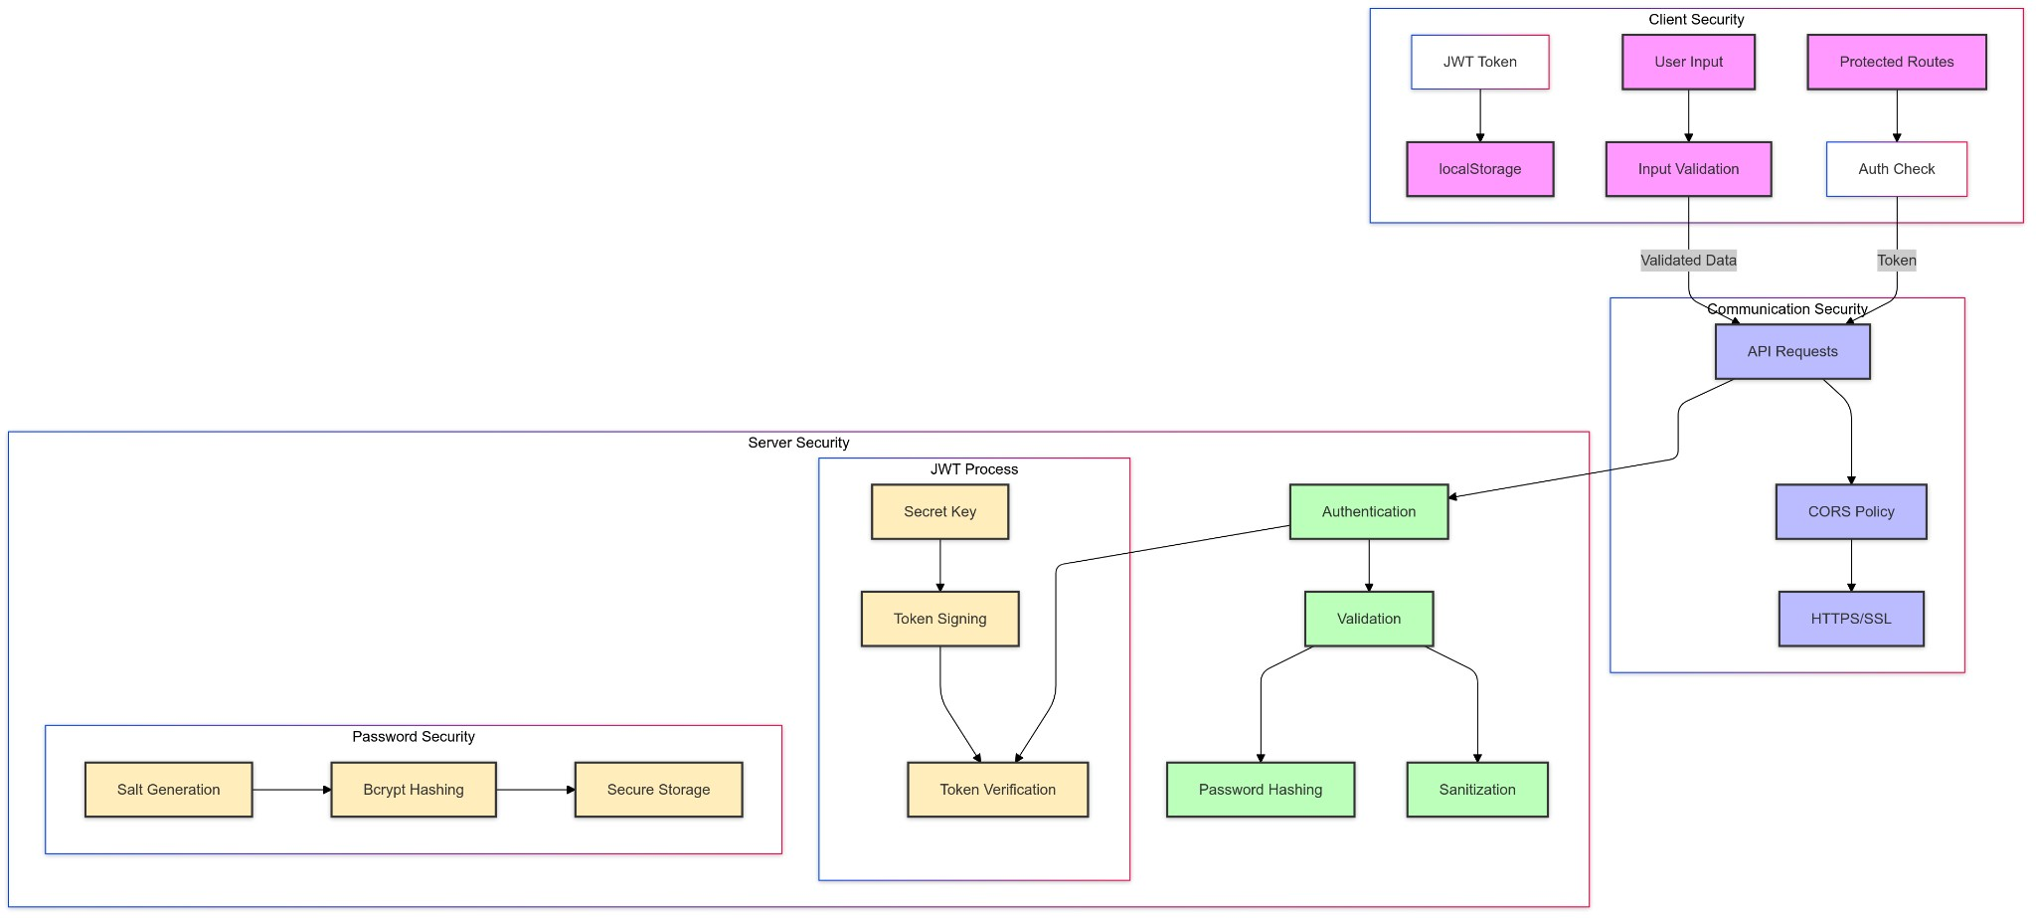

# Deployment Plans

## Environment Setup

* **Backend Environment Variables**:
  1. PORT: Port number for the server.

○ DB_CONNECTION_STRING: MongoDB connection URI.

○ JWT_SECRET: Secret key for signing JWTs.

* **Frontend Environment Variables**:
  1. VITE_API_URL: Base URL for the backend API.

## Deployment Steps

1. **Backend Deployment**:
   1. Host on platforms like Heroku, AWS EC2, or DigitalOcean.

○ Ensure environment variables are securely set.

○ Use process managers like PM2 for process management.

1. **Frontend Deployment**:
   1. Build the React application using npm run build.

○ Host static files on services like Vercel or AWS.

1. **Domain and SSL**:
   1. Configure a custom domain.

○ Set up SSL certificates for secure HTTPS communication.

1. **Database Hosting**:
   1. Use managed MongoDB services like MongoDB Atlas. ○ Configure IP whitelisting and security measures.
2. **Continuous Deployment**:
   1. Set up CD pipelines to automatically deploy on code changes. ○ Use GitHub Actions or other CI/CD tools.

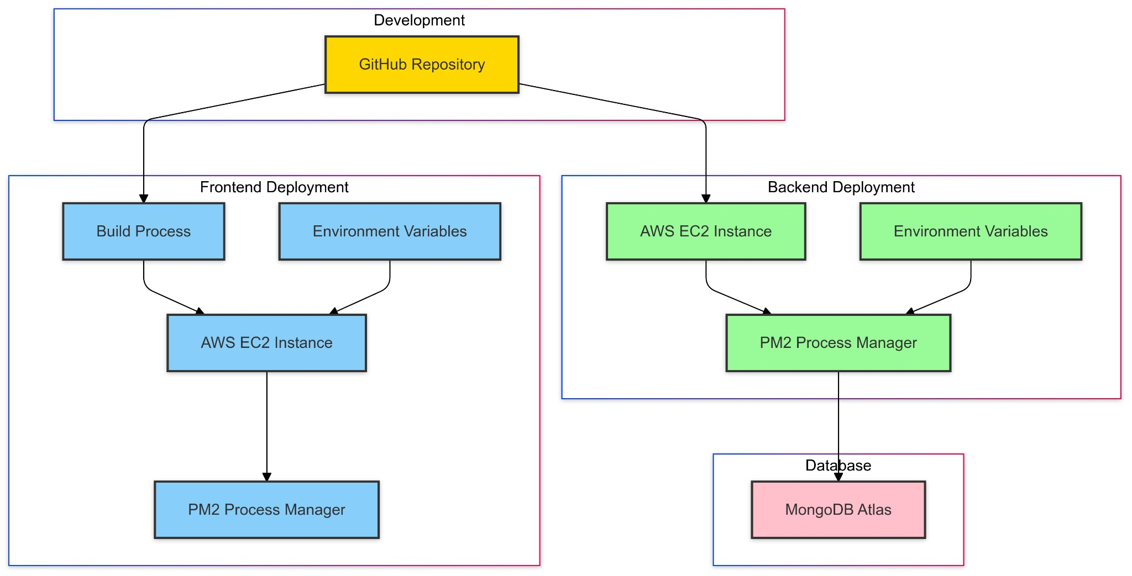

# Future Enhancements

## Technical Improvements

* **Switch to TypeScript**:
  1. Introduce TypeScript for type safety and better maintainability.
* **State Management Library**:
  1. Implement Redux or Context API for more complex state needs.
* **WebSockets**:
  1. Use [Socket.IO](http://socket.io/) for real-time features like live comments or notifications.

## Feature Enhancements

* **Comment System**:
  1. Allow users to comment on articles.
* **User Following**:
  1. Implement a social feature where users can follow others.
* **Notifications**:
  1. Real-time notifications for interactions.
* **Search Functionality**:
  1. Implement search to find articles by title, content, or tags.
* **Analytics Dashboard**:
  1. Provide users with insights on article views and interactions.

# Conclusion

The MarkIt project is a full-stack web application that I've developed using modern technologies to ensure scalability, security, and a great user experience. By using React.js for the frontend, Express.js and Node.js for the backend, and MongoDB as our database, I've created a seamless platform for knowledge sharing.

During development, there was an emphasis on clear architecture with well-organized frontend and backend directories, modular components and well-defined routes.

Working on MarIt has taught me a lot about web development and the importance of user-centered design. It is truly a fun experience.